**Web Based Healthy Food Ordering and Restaurant Management System in PHP**



**A Project Paper**

Submitted in the Partial Fulfillment of the Requirements for the B. Sc (Engineering) 3rd Year 2nd Semester Examination in Information and Communication Engineering.

**B.Sc. (Engineering), 3rd Year 2nd Semester, Exam-2020**

Course Code: ICE-3211

Course Title: Project Design and Development

Project Supervised By

**Md. Tofail Ahmed**

Lecturer

Department of Information and Communication Engineering

Pabna University of Science and Technology, Bangladesh

Submitted By

**Md. Abu Yousuf**

Roll No: 180640

Registration No: 1065323

Session: 2017-2018

**Department of Information and Communication Engineering**

**Pabna University of Science and Technology**

**Pabna-6600, Bangladesh.**

**Acknowledgement**

First and foremost, I would like to thank ALLAH (omnipotent) for giving me strength, patience and ability to round off this study. I express my deepest gratitude and thanks to my honorable project supervisor Md. Tofail Ahmed, Lecturer, Department of Information and Communication Engineering, Pabna University of Science and Technology, Pabna 6600, Bangladesh, for his excellent supervision and constructive advice, total support, constant inspiration and continuous encouragement which had contributed a lot to the completion of this project.

I am especially pleased and thankful to him for allowing me to work under his supervision.

I would like to convey my gratitude to honorable chairman, Dr. Md. Omar Faruk, Department of Information and Communication Engineering to carry out the present research work in the modern trend of Web Based Healthy Food Orderingcreation and all the members of examination committee for their help to accomplish my project.

Last but not least, I would like to thank my parents for their blessing and love as well as my brothers and sisters for their constant support and encouragement.

Md. Abu Yousuf

**Abstract**

To live a healthy and happy life, eating healthy food regularly is essential for all of us. Health-Conscious people regularly search for wholesome weight loss plans and healthful meals online but it's no longer that without difficulty available. Acknowledging this problem, in this project we have tried to build a website that will guide us to our healthy diet and categorize our life stages into four main stages: child, teenage, adult and old. In addition, this website will have foods suitable for specialized children, physically challenged people and many more categories could be added. Our website will provide healthy food for all the stages and one can easily find suitable, healthy food for them. Furthermore, an admin can control the whole website without getting in any trouble. The admin can control things like: maintaining the database, maintaining categories, maintaining foods, and maintaining orders. Last but not the least, the whole project is written in with the help of HTML, CSS, BOOTSTRAP, PHP, JAVASCRIPT, and MYSQL Database.

**­**

**Table of Contents**

|  |  |  |  |  |
| --- | --- | --- | --- | --- |
| **Contents** | | | | **Page No** |
| **Acknowledgement** | | | | i |
| **Abstract** | | | | ii |
| **Chapter-1: Introduction** | | | | 1-7 |
| 1.1 | Background | | | 2 |
| 1.2 | Introduction | | | 2 |
| 1.3 | Motivation | | | 3 |
| 1.4 | Objectives | | | 3 |
| 1.5 | Challenges | | | 4 |
| 1.6 | Problem Statement | | | 4 |
| 1.7 | Proposed Solution | | | 5 |
| 1.8 | Process Modelling | | | 5-6 |
| 1.9 | System Model | | | 7 |
| **Chapter -2: Language Used and E-Marketing Scops** | | | | 8-11 |
| 2.1 | Language Used | | | 9-10 |
|  | 2.1.1 | | HTML | 9 |
|  | 2.1.2 | | CSS | 9 |
|  | 2.1.3 | | BOOTSRAP | 9 |
|  | 2.1.4 | | JavaScript | 9 |
|  | 2.1.5 | | PHP | 10 |
|  | 2.1.6 | | MYSQL | 10 |
| 2.2 | Web Marketing | | | 10-11 |
|  | 2.2.1 | | Search Engine Optimization (SEO) | 11 |
|  | 2.2.2 | | Search Engine Marketing (SEM) | 11 |
|  | 2.2.3 | | Social Media Marketing | 11 |
|  | 2.2.4 | | Web Marketing | 11 |
|  | 2.2.5 | | Software Development | 11 |
| **Chapter -3: Website Development Process** | | | | 12-14 |
| 3.1 | Various Steps of Website Development Process | | | 13 |
|  | 3.1.1 | | Analysis | 13 |
|  | 3.1.2 | | Specification | 13 |
|  | 3.1.3 | | Design and Development | 13 |
|  | 3.1.4 | | Content Writing | 13 |
|  | 3.1.5 | | Coding | 13 |
|  | 3.1.6 | | Testing and Security | 13 |
| 3.2 | Actual Implementation | | | 14 |
| **Chapter-4: Database Tables** | | | | 15-18 |
| 4.1 | Tables | | | 16-18 |
| **Chapter-5: Implementation and Results** | | | | 19-25 |
| 5.1 | Homepage | | | 20 |
| 5.2 | Admin Login | | | 22 |
| 5.3 | Admin Dashboard | | | 22 |
| 5.4 | Category | | | 23 |
| 5.5 | Foods | | | 24 |
| 5.6 | Order | | | 25 |
| **Chapter-6: Conclusion and Future Work** | | | | 26-27 |
| 6.1 | Conclusion | | | 27 |
| 6.2 | Future Work Scops | | | 27 |
|  | 6.2.1 | App Development | | 27 |
|  | 6.2.2 | Customer Feedback | | 27 |
|  | 6.2.3 | Offers for Customers | | 27 |
|  | 6.2.4 | Time to serve | | 27 |
|  | 6.2.5 | Sorting and Item | | 27 |
|  | 6.2.6 | Google Map API | | 27 |
| **References** | | | | 28 |

***CHAPTER 1***

***INTRODUCTION***

***INTRODUCTION***

**1.1 Background**

The World Wide Web (WWW) was created in 1989 by the British CERN computer scientist Tim Berners-Lee. On 30 April 1993, CERN announced that the World Wide Web would be free to use for anyone, contributing to the immense growth of the Web. Before the introduction of the Hypertext Transfer Protocol (HTTP), other protocols such as File Transfer Protocol and the gopher protocol were used to retrieve individual files from a server. These protocols offer a simple directory structure in which the user navigates and where they choose files to download. Documents were most often presented as plain text files without formatting or were encoded in word processor formats.

A website (also written as a web site) is a collection of web pages and related content that is identified by a common domain name and published on at least one web server. Examples of notable websites are Google, Facebook, Amazon, and Wikipedia. All publicly accessible websites collectively constitute the World Wide Web. There are also private websites that can only be accessed on a private network, such as a company's internal website for its employees. Websites are typically dedicated to a particular topic or purpose, such as news, education, commerce, entertainment, or social networking. Hyperlinking between web pages guides the navigation of the site, which often starts with a home page. Users can access websites on a range of devices, including desktops, laptops, tablets, and smartphones. The app used on these devices is called a web browser [1].

**1.2 Introduction**

“Web Based Healthy Food Ordering and Restaurant Management System in PHP'' is a web developing. This system is developed to automate day to day activity of a restaurant. Restaurant is a kind of business that serves people all over the world with ready-made food. This system is developed to provide service facilities to restaurants and also to the customer. This restaurant management system can be used by employees in a restaurant to handle the clients, their orders and can help them easily find free tables or place orders. The services that are provided are food ordering and reservation table management by the customer through the system online, customer information management and waiter information management, menu information management and report. The restaurant menu is organized by categories (Child, Teenage, Adult, Old) of menu items. Main objective of the system is to provide healthy food ordering and reservation service online to the customer. Each menu item has a name, price and associated recipe. A recipe for a menu item has a chef, preparation instructions and associated ingredients. With this system online, ordering and reservation management will become easier and systematic to replace traditional systems where they are still using paper. To register a meal online, the customer has to become a member first then he can access the later part of the site. this project to facilitate customers to make online ordering and reservations. The option of becoming a member was only an attempt to avoid (to some extent) placing the fake bookings. Online Restaurant management system is the system for managing the restaurant business. After successful login the customer can access the menu page with the items listed according to the desired time. The main point of developing this system is to help restaurant administrators manage the restaurant business and help customers for online ordering and reserve tables. In the proposed system, the user can search for a menu according to his choice i.e., according to price range and category of food and later he can order a meal. The project is developing because; many restaurants have a lot of difficulty managing the business such as customer ordering and reservation tables. If the customer books an order and later wants to cancel the order, he is permitted to do this only within a specific time period. By using manual customer ordering it is difficult for the waiter to keep the correct customer information and maybe lose the customer information. The customer is also given the facility to view the status of the order and if the order is ready then he can go and get it [2].

**1.3 Motivation**

Many people in this country actually struggles to find healthy food for them. They know a little about what they should eat to stay healthy and fit. People who want to stay healthy and happy We actually worked for them; we’ve tried this type of platform where every person is free to choose their food. In addition to that, people can find regular food here as well. So that’s one of the biggest motivations for us to work with such website that can help people over the country also could help across world.

**1.4 Objectives**

The main objective of this project is to provide food for people easy and convenient way.

Objectives of this project are given below:

* Provide healthy food for people with reasonable price, less amount of hassle to endure, rich in number of food menus.
* Provide aesthetic user interface that’ll give customer/user the faster page load experience without any bug in the webpage.
* Webpage that can handle any unexpected, unauthorized attacker, webpage that will be protected from the hacker.
* Website that can be controlled by an admin, without admin login or admin no unauthorized user will have the access to the restaurant/webpage related sensitive data.
* An authorized admin can maintain the whole database without any type of hassle.
* An authorized admin can add more categories of food, can delete the category if necessary, and can update the specific category with permission.
* An authorized admin can add more foods if available in the restaurant, can delete individual food, and can update specific food if required.
* An authorized admin can maintain orders. He or She can decide the order is on delivery, ordered, delivered, or cancelled.

**1.5 Challenges**

Throughout this project we’ve found some difficulties. If we knew that before the project that would help us to do it more less time.

There are some challenges such as:

* Availability of the Local Foods.
* Better idea about healthy foods and customer’s demand.
* Device performance need to be up to the mark.
* Real-life problem-solving ability.
* Coding needs to be clean and editable.
* Comment should be used in codding for better understanding.

**1.6 Problem Statement**

1. In the present scenario people have to physically visit the hotels or restaurants for eating food, and have to make payment through cash mode most of the times due to unawareness of advanced technologies at certain places.
2. In this method time as well as physical work is required, among which time is something that no one has in ample amount. The traditional food ordering procedure is not efficient enough for hotels and restaurant, as they have to deal with crowd, in their restaurant.
3. The old methods can be classified into categories which are paper grounded and verbal grounded. For paper-based work, the waiter comes and pens down foods that customers order and pass the food list containing paper to the chefs or cooks in the kitchen for further process.
4. Also, from the owner’s point of view maintaining data record and the accounts in physical file is cumbersome and tedious work to do. And also, it is full of risk as anyone can access it and modify the data.

**1.7 Proposed Solution**

1. This system is a bunch of benefits from various point of views. As this online application enables the end users to register to the system online, select the food items of their choice from the menu list, and order food online.
2. Also, the payment can be made through online mode or at the time of home delivery depending upon the customer’s choice and convenience. The selection made by the customers will be available to the hotel reception or to the person handling work assignment.
3. Now this same person will assign the orders to the specialist chef to be completed within a fixed duration of time.
4. As soon as the chef prepares the food, the later person forwards the parcels to the delivery persons assigned with the location and customer identity of the customer along with the bill status.
5. With this application the work load of the waiter in the hotels are reduced or in some situations the work is abolished.
6. One of the various benefits of this is system is that if there is rush or a huge crowd present in the restaurant then in that case sometimes unavailability of tables cut downs the restaurants customer.

**1.8 Process Modelling**

Process modelling is a technique used to organize and document the structure and flow of data between logical processes. The modelling process involved is Context diagram, data flow diagram, Activity Diagram, flow chart.

Request

Admin

Admin

0.0

Food System

Request

Response

Response

**Figure 1.1: Context Diagram of Process Modelling.**

Response

Admin

Admin Manager

Food

Order

Dashboard

1.0

2.0

3.0

4.0

5.0

Manage admin

Manage Order

Manage food

Revenue Generated

Request for Login

Accepted/Rejected

Check Admin Details

Check Food Details

Check Order Details

Check Dashboard Details

Response

Response

Response

Manage Admin(add, delete,update)

Response

Response

Response

Response

Manage Food(add,delete,update)

Manage Order(add,delete,update)

Request for View Revenue

**Figure 1.2:** **Admin side DFD for Online Food Ordering System.**

Figure 1.2 show an Admin side Data-Flow Diagram (DFD) for online food system. In this process the admin will interact and give the username and the password that the admin has registered before. The login data next will be search in the database whether it has registered or not. If the user registers, the user login data will remain the same. The login was successful after finding comparable data [3].

**1.9 System Model**

Project model design is one of the important tasks for any project. Project model shows us in which track we should go to reach our destination with less amount of time and conveniently. Figure 1.3 show the complete project model, Where the main webpage is a dynamic page and there will be two portions of the main webpage. First, Common part of the webpage open to all visitors/customers where customers can explore foods, search for foods, order their desired food, for betterment they can make complain as well. Second, for admin panel, where an authorized admin can make changes contents of the main webpage.

Webpage

Admin Panel

Admin Dashboard

Maintain Database

Add/Delete Category

Update Category

Update Order Status

Work-On Orders

Add/Delete Foods

Common Part  
(Visible to all visitors)

Search Food

Make Complain

Order Food

Explore Food

**Figure 1.3: Block Diagram of System Model.**

***Chapter 2***

***Language Used and E-Marketing Scops***

**2.1 Languages Used**

**2.1.1 HTML:** In communicating, what better way is there to share and collect information worldwide than the Internet? In navigating, the revolution that HTML has brought to electronic information and the real capacity to link tiny fragments of information into a vast network of highly relevant knowledge is now fully accepted by all. Concerning transparency, HTML is a mark-up language. Markup languages have been with us some time. Generalized Mark-up Language was born out of some early work by IBM. This evolved into Standard Generalized Mark-up Language (SGML) which has an IS0 rating of 8879 (established in 1986 and revised in 1988). SGML has had considerable success in the publishing field and is extensively used in the area of technical documentation in both the military and aeronautical sectors. Its value in those areas where information has a very high intrinsic value is clear, so why not use it in the area of medicines? HTML can be considered a series of marks within SGML which enable the positioning of the now famous hypertext links and hence provide immense navigation power. Today, therefore, HTML alone can achieve all the needs of the fully electronic submission [4].

**2.1.2 CSS:** Cascading Style Sheets (CSS) is a language mainly used for describing the presentation of HTML documents. Along with JavaScript, CSS is a cornerstone technology used to develop web applications. The massive adoption of the language has led to a significant increase of the average size of CSS code. Indeed, nowadays, web applications often contain several thousands of lines of CSS code, and consequently a large amount of duplication. Duplicated code in software systems is known to complicate code maintenance and evolution, as fault fixes and changes must be propagated in multiple places. Therefore, software developers tend to keep the amount of duplicated code as low as possible [5].

**2.1.3 Bootstrap:** Bootstrap is a free and open-source tool collection for creating responsive websites and web applications. It is the most popular HTML, CSS, and JavaScript framework for developing responsive, mobile first web sites. Bootstrap is a framework to help you design websites faster and easier. It includes HTML and CSS based design templates for typography, forms, buttons, tables, navigation, modals, image carousels, etc. [2].

**2.1.4 JavaScript:** JavaScript is a client-side programming language which helps web developers to do Web Application Development and make dynamic and interactive web pages by implementing custom client-side scripts. Developers can also use cross-platform runtime engines like Node.js to write server-side code in JavaScript. Developers can also create web pages which works well across various browsers, platforms, and devices by combining JavaScript, HTML5, and CSS3 [2].

**2.1.5 PHP:** PHP code is usually processed on a [web server](https://en.wikipedia.org/wiki/Web_server) by a PHP [interpreter](https://en.wikipedia.org/wiki/Interpreter_(computing)) implemented as a [module](https://en.wikipedia.org/wiki/Plugin_(computing)), a [daemon](https://en.wikipedia.org/wiki/Daemon_(computing)) or as a [Common Gateway Interface](https://en.wikipedia.org/wiki/Common_Gateway_Interface) (CGI) executable. On a web server, the result of the [interpreted](https://en.wikipedia.org/wiki/Interpreter_(computing)) and executed PHP code – which may be any type of data, such as generated [HTML](https://en.wikipedia.org/wiki/HTML) or [binary](https://en.wikipedia.org/wiki/Binary_number) image data – would form the whole or part of an [HTTP](https://en.wikipedia.org/wiki/Hypertext_Transfer_Protocol) response. Various [web template systems](https://en.wikipedia.org/wiki/Web_template_system), web [content management systems](https://en.wikipedia.org/wiki/Content_management_system), and [web frameworks](https://en.wikipedia.org/wiki/Web_framework) exist which can be employed to orchestrate or facilitate the generation of that response. Additionally, PHP can be used for many programming tasks outside the web context, such as standalone [graphical applications](https://en.wikipedia.org/wiki/Graphical_user_interface) and [robotic](https://en.wikipedia.org/wiki/Robotics) [drone](https://en.wikipedia.org/wiki/Unmanned_aerial_vehicle) control. PHP code can also be directly executed from the [command line](https://en.wikipedia.org/wiki/Command-line_interface) [6].

**2.1.6 MySQL:** MySQL is an [open-source](https://en.wikipedia.org/wiki/Open-source_software) [relational database management system](https://en.wikipedia.org/wiki/Relational_database_management_system) (RDBMS).Its name is a combination of "My", the name of co-founder Wideness’s daughter My, and "SQL", the abbreviation for [Structured Query Language](https://en.wikipedia.org/wiki/Structured_Query_Language). A [relational database](https://en.wikipedia.org/wiki/Relational_database) organizes data into one or more data tables in which data may be related to each other; these relations help structure the data. SQL is a language programmers use to create, modify and extract data from the relational database, as well as control user access to the database. In addition to relational databases and SQL, an RDBMS like MySQL works with an [operating system](https://en.wikipedia.org/wiki/Operating_system) to implement a relational database in a computer's storage system, manages users, allows for network access and facilitates testing database integrity and creation of backups. MySQL is [free and open-source software](https://en.wikipedia.org/wiki/Free_and_open-source_software) under the terms of the [GNU General Public License](https://en.wikipedia.org/wiki/GNU_General_Public_License), and is also available under a variety of [proprietary](https://en.wikipedia.org/wiki/Proprietary_software) licenses. MySQL was owned and sponsored by the [Swedish](https://en.wikipedia.org/wiki/Sweden) company [MySQL AB](https://en.wikipedia.org/wiki/MySQL_AB), which was bought by [Sun Microsystems](https://en.wikipedia.org/wiki/Sun_Microsystems) (now [Oracle Corporation](https://en.wikipedia.org/wiki/Oracle_Corporation)). In 2010, when Oracle acquired Sun, Wadena’s [forked](https://en.wikipedia.org/wiki/Fork_(software_development)) the [open-source](https://en.wikipedia.org/wiki/Open-source) MySQL project to create [MariaDB](https://en.wikipedia.org/wiki/MariaDB) [7].

**2.2 E-Web Marketing**

Digital marketing strategies may include the use of one or more online channels and techniques to increase brand awareness among consumers. Building brand awareness may involve such methods/tools as:

**2.2.1 Search Engine Optimization (SEO):** Search engine optimization techniques may be used to improve the visibility of business websites and brand related content for common industry-related search queries. The importance of SEO to increasing brand awareness is said to correlate with the growing influence of search results and search features like featured snippets, knowledge panels and local SEO on customer behavior.

**2.2.2 Search Engine Marketing (SEM):** SEM, also known as PPC advertising, involves the purchase of ad space in prominent, visible positions atop search results pages and websites. Search ads have been shown to have a positive impact on brand recognition, awareness and conversions. 33% of searchers who click on paid ads do so because they directly respond to their particular search query.

**2.2.3 Social Media Marketing:** 70% of marketers list increasing brand awareness as their number one goal for marketing on social media platforms. Facebook, Instagram, Twitter and YouTube are listed as the top platforms currently used by social media marketing teams.

**2.2.4 Web Marketing:** Web marketing is the process of using the Internet to market your business. It includes the use of social media, search engines, blogging, videos, and email. Promoting a business takes effort. There are a variety of ways to do it. Traditional advertising in newspapers, on the radio and television, direct mail, and billboards has been around for decades. Web marketing takes your message to the big wide web. With tons of people using the internet every day, there are huge opportunities to get your product or service in front of people who need or want it.

**2.2.5 Software Development:** Software development is the collective processes involved in creating software programs, embodying all the stages throughout the systems development life cycle. SDLC methodologies support the design of software to meet a business need, the development of software to meet the specified design and the deployment of software to production. A methodology should also support maintenance, although that option may or may not be chosen, depending on the project in question [2].

***Chapter 3***

***Website Development Process***

**3.1 Various Steps of Website Development Process**

**3.1.1 Analysis:** Firstly, better understand the website requirement creation, including website Design and Website looks and feels, the Web pages uses, website content and for suggestion and discussions, a proper space available on a web site for easily approachable.

**3.1.2 Specification:** Predicated on Requisite, prepare a draft designation of Web pages to be developed include the sitemap and a flow of various process.

**3.1.3 Design & Development:** Invention and Development plays a significant role in Web Development. Graphical looks and feel according to the most impressive and efficient way, Graphical elements required for design are appearing more impressive, for this use color and image. Design of web pages, computer graphic includes navigation mock- up, template content and placeholders.

**3.1.4 Content Writing:** Writing of contents is a significant part of development of web pages and plays an important and necessary step in the optimization Engine, a well-defined or easy content is utterly necessary to fall in internet site users. Content written by a more professional requires more pure, easy and accurate content.

**3.1.5 Coding:** Coding start of a Web Pages in CSS, HTML, Java scripts and other technologies of WWW (world wide web), for drawing of the graphic and text contents, we look at the code of web pages constantly like as web page design. Coding of a web page is loading firstly search engine and index give us rank very quickly. Every web page of a website takes a unique title, unique meta tags as keywords and descriptions. We can create links of internal with keywords of website to explore the search engine ranking and navigation.

**3.1.6 Testing & Security:** Testing as well play an important role in website development, testing is done for browser compatibility, broken links and can check the speed of loading pages, and loading speed of images. We can also check validation of HTML code, validation of CSS, checking of spelling and build alterations to rectification of mistakes and can perform test of functional on processes of websites like payment, postal services, registration, etc., these checks as per requirement.

**3.1.7 Promotion:** The advancements are likewise a necessary step for website to awareness of the peoples. To become more impressive, we can do website promotion that are listed below: • E-mails • Social-media • Web logs • Articles • Blog.

**3.2 Actual Implementation:**

In our project we created a Web Based Healthy Food Ordering and Restaurant Management System in PHPwhich has the complete information of items and their services. This Website which is developed with some ideas and portability purposes that may help some fresher to look around it and may show some interest against the restaurant management by doing some enquiry through these websites. Here the data is arranged properly by which its updating will be easier in future as the requirement or demand increases towards the website. It contains updated and useful data for restaurant management. We have used platform HTML, CSS, BOOTSTRAP, PHP, MYSQL, JAVASCRIPT for our restaurant management [2].

***Chapter 4***

***Database Tables***

**4.1 Tables**

XAMPP is a [free and open-source](https://en.wikipedia.org/wiki/Free_and_open-source) [cross-platform](https://en.wikipedia.org/wiki/Cross-platform) [web server](https://en.wikipedia.org/wiki/Web_server) [solution stack](https://en.wikipedia.org/wiki/Solution_stack) package developed by Apache Friends, consisting mainly of the Apache HTTP server, MariaDB database, and [interpreters](https://en.wikipedia.org/wiki/Interpreter_(computing)) for scripts written in the PHP and Perl programming language. Since most actual web server deployments use the same components as XAMPP, it makes transitioning from a local test server to a live server possible [8]. It makes the system more accessible, less time-consuming, and increases usability. All information of users is stored in a database table. Some necessary tables are bellowed:

Table 4.1. Table of Admin

|  |  |  |  |  |
| --- | --- | --- | --- | --- |
| **SL** | **Field Name** | **Data Type** | **Null** | **Description** |
| 1 | Full Name | Varchar (100) | No | Store full name of the admin |
| 2 | User Name | Varchar (100) | No | Store user name of the admin |
| 3 | Password | Varchar (150) | No | Store password which will be encrypted |

Table 4.1 represents table structure of admin database, Here the record of all admin is stored. Without admin login no one can access the main admin dashboard.

Table 4.2. Table of Categories

|  |  |  |  |  |
| --- | --- | --- | --- | --- |
| **SL** | **Field Name** | **Data Type** | **Null** | **Description** |
| 1 | Title | Varchar (100) | No | Store title of the food category |
| 2 | Image Name | Varchar (255) | No | Store image as image name of the food category |
| 3 | Featured | Varchar (10) | No | Store featured value ‘Yes’ or ‘No’ |
| 4 | Active | Varchar (10) | No | Store active value ‘Yes’ or ‘No’ |

Table 4.2 represents table structure of food category database, Here the record of all categories is stored. Title of the food is stored as title. Image is stored as an image name. The featured and active value can be either ‘Yes’ or ‘No’.

Table 4.3. Table of All Existing Foods

|  |  |  |  |  |
| --- | --- | --- | --- | --- |
| **SL** | **Field Name** | **Data Type** | **Null** | **Description** |
|  | Title | Varchar (150) | No | Store title of the food category |
|  | Description | Varchar (255) | No | Store description of the food |
|  | Price | Decimal (10,2) | No | Store price of the food |
|  | Image Name | Varchar (255) | No | Store image as image name of the food category |
|  | Category Id | Int (10) | No | Store category id of the food |
|  | Featured | Varchar (10) | No | Store featured value ‘Yes’ or ‘No’ |
|  | Active | Varchar (10) | No | Store active value ‘Yes’ or ‘No’ |

Table 4.3 represents table structure of all existing foods of the database, Here the record of all foods stored. Title of the food is stored as title. Description of the food is stored as description. Price of the food is stored as price. Category Id is the same as category added to the table category database. Image is stored as an image name. The featured and active value can be either ‘Yes’ or ‘No’.

Table 4.4. Table of All orders.

|  |  |  |  |  |
| --- | --- | --- | --- | --- |
| **SL** | **Field Name** | **Data Type** | **Null** | **Description** |
|  | Category Id | Varchar (150) | No | Store id of the food category |
|  | Price | Decimal (10,2) | No | Store price of the food |
|  | Quantity | Int (10) | No | Store quantity of the food |
|  | Total | Varchar (255) | No | Store total price of the food |
|  | Order Date | Int (11) | No | Store date of order |
|  | Status | Varchar (10) | No | Store order status |
|  | Customer Name | Varchar (150) | No | Store name of the customer |
|  | Customer Contact | Varchar (150) | No | Store contact number of the customer |
|  | Customer Email | Varchar (150) | No | Store email of the customer |
|  | Customer Address | Varchar (255) | No | Store address of the customer |

Table 4.4 represents table structure of all food orders of the database, Here the record of all food orders is stored. Quantity represents total quantity of the food customer needed. Total price is calculated and stored as Total. Order date, Status, Customer name, Customer contact, Customer email, Customer address all are stored respectively.

***Chapter 5***

***Implementation and Results***

This chapter refers to how the main parts of the system are being implemented. There are several interfaces that make up the entire system that are briefly described below.

**5.1 Home Page:** Home page of the restaurant looks like figure 5.1. This is a dynamic home page for the restaurant, All the categories and foods are coming from the database. This home page is fully responsive. In this home page we have our desired option in the menu bar as well as in the main web page. The interface of homepage and searching. Customers can know the total quantity of each product, price of each product, and the total price order on the food page. All the products will be displayed in this searching module. Customers can directly use the keyword to increase the speed of searching the item in the searching module. Customer can go any page from the home. If any customer needs to save time, he/she can go through the Foods page where Total food will be shown. Customer can easily order any food from the homepage.

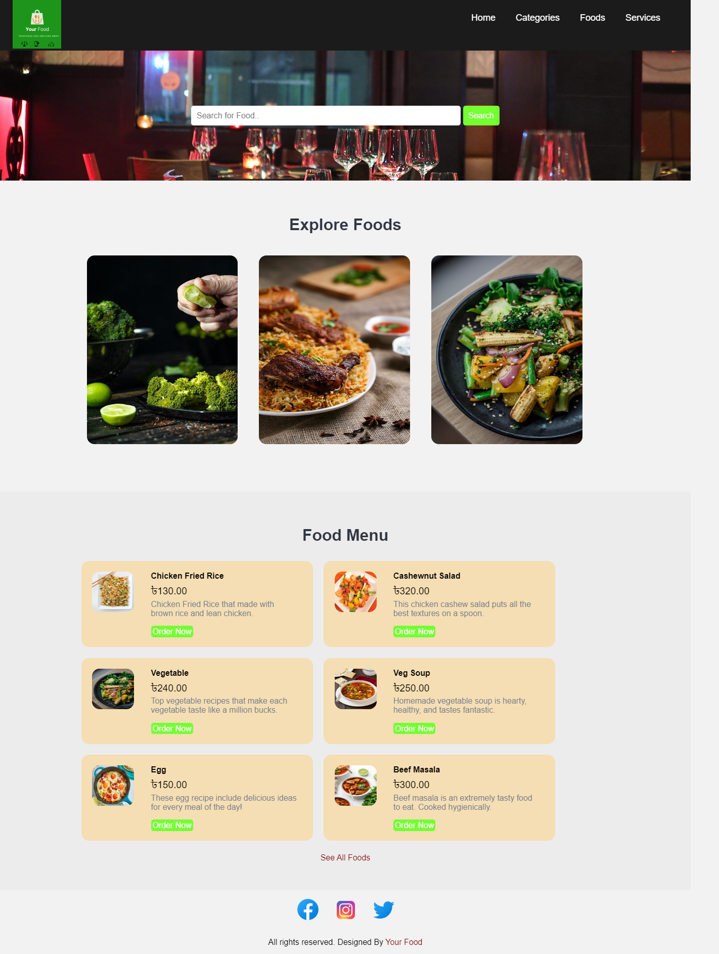

**Figure 5.1: Customer's Home Page.**

**5.2 Admin Login:** One of the simple admin login pages showed in figure 5.2. An admin can’t access the admin dashboard without logged in. An authorized admin will have all the access to the admin dash board. Admin dashboard contains some very important information like total revenue, total categories and more. Admin can easily monitor all the important information regarding the restaurant and make report what’s going on in the restaurant.

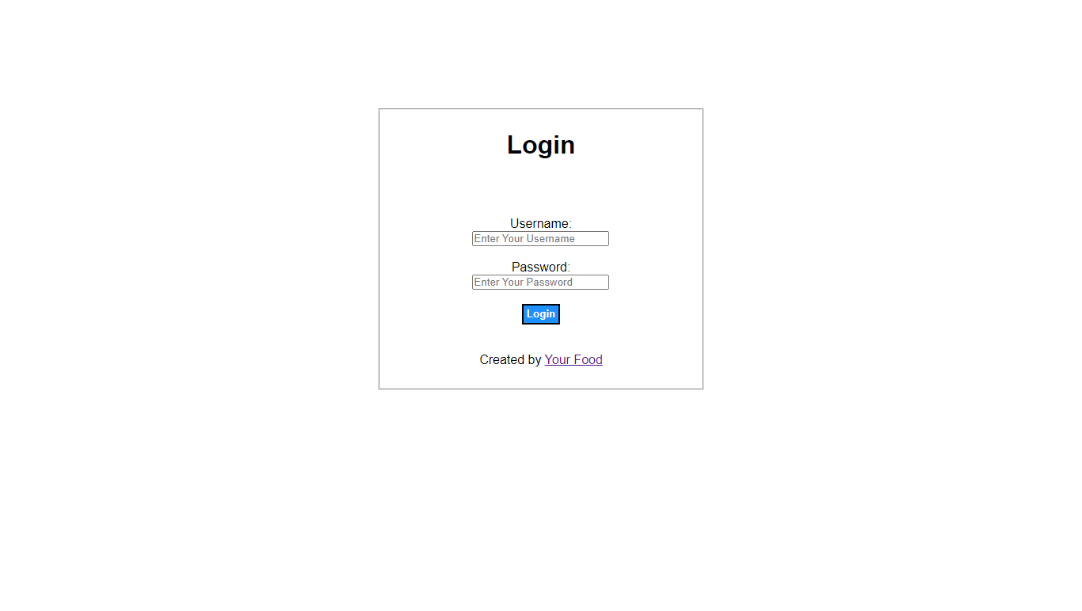

**Figure 5.2: Simple Admin Login Page.**

**5.3 Admin Dashboard:** Admin dashboard contains categories, total foods, total orders and generated revenue. Showed in figure 5.3. It will show the homepage of admin after the admin login into the web based successfully. Admin login password protected via md5 encryption. MD5 is short for Message-digest Algorithm 5, developed by the MD2, MD3 and MD4.It is the length of bytes at a series of changes in the length of a large integer.MD5 algorithms are based on MD4 increasing the notion of safety- belts. Though MD5 is a little slower than MD4, it is safer. This algorithm is marked by four stages which is little different from MD4 design. In Md5 algorithms, the size and fill of information abstract is all the same with MD4.Due to the use of Md5 algorithm needn't have any copyright fees, under common circumstances MD5 is a very good middle technique [9].

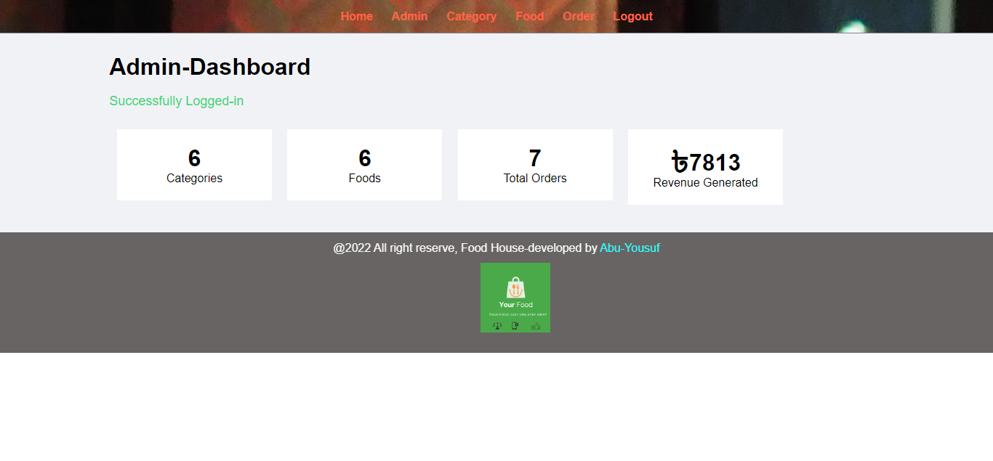

**Figure 5.3: Admin Dashboard.**

**5.4 Category:**  Manage-Category page shows some functionality to maintain categories. An authorized Admin can maintain category. He or She can add more category if there is available more category which will make this restaurant more attractive to customers, can delete category if certain category is not available anymore, can update category such as updating the old and low-quality picture to the new and high-resolution picture for better understanding. Manage Food category by admin Showed in figure 5.4.

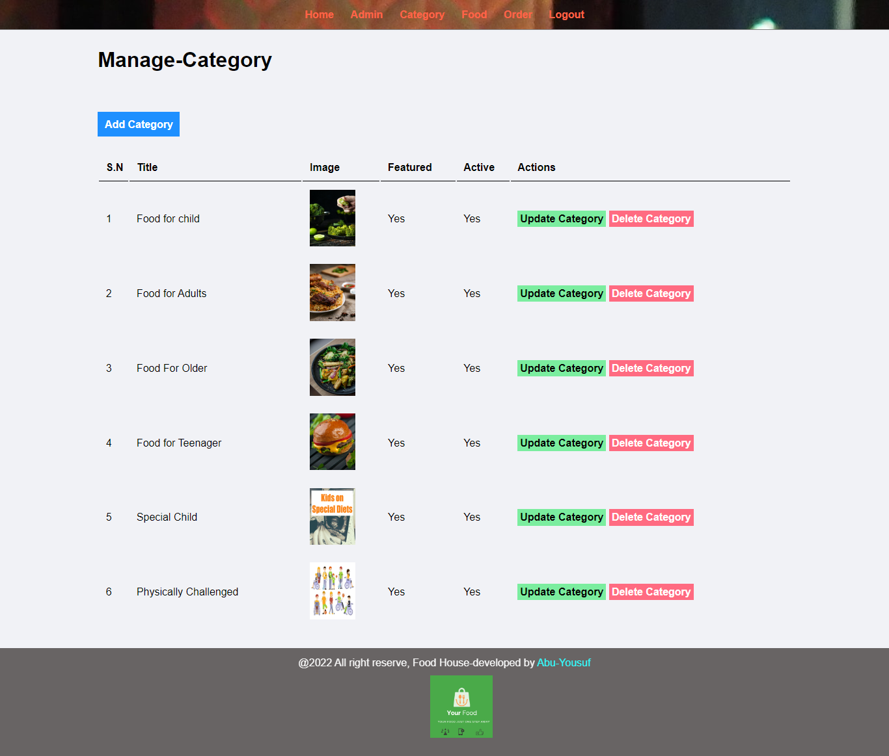

**Figure 5.4: Manage Food Category by Admin.**

**5.5 Food:** In the food page total number of foods that is available will be shown, and it is maintained by the admin panel. Shown in the figure 5.5. interface of information management module. Admin can manage information such as edit, delete, and update the name, image, price of each food in the information management module. Featured and Active can either be “Yes” or “No” and admin can use this as some functionality to show foods on the food page.

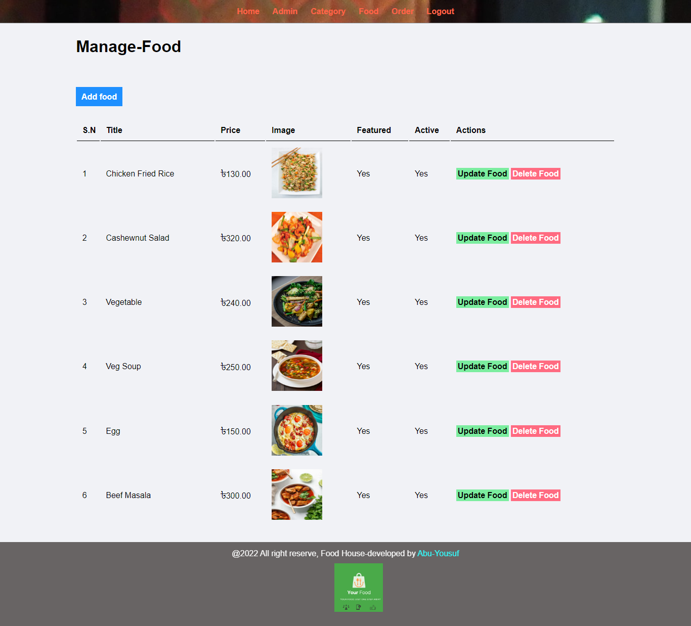

**Figure 5.5: Publish Food Items and Price by Admin.**

**5.6 Order:** Maintenance of the order done by Admin. Showed in figure 5.6. it shows the manage order page that is delivery status module. Admin can change the status of the order form customer in the delivery status module. Admin can decide the order is on delivery, ordered, delivered, or cancelled.

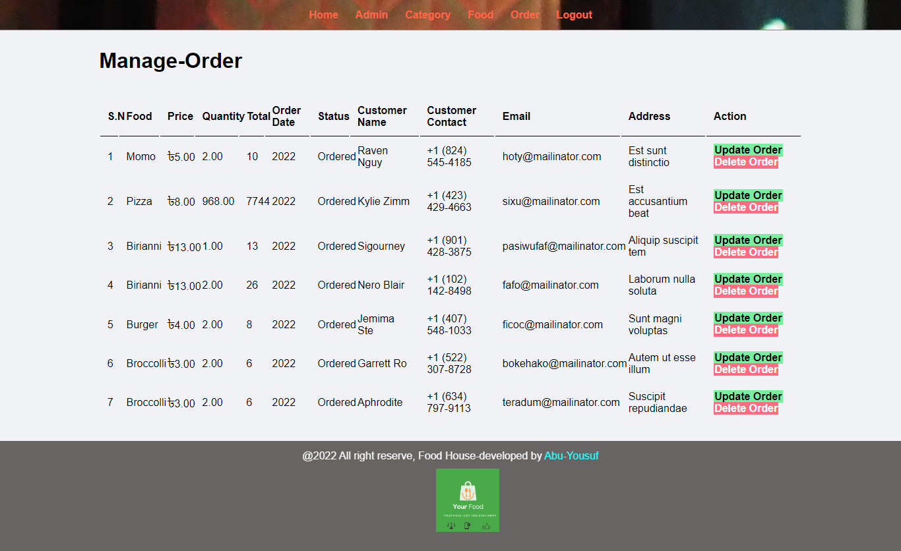

**Figure 5.6: Maintenance of the Order from The Customer.**

***Chapter 6***

***Conclusion and Future work***

**6.1 Conclusion**

In conclusion, it can be said that a health conscious, integrated, reliable, error free, fast, Web Based Healthy Food Ordering and Restaurant Management System has been developed in this project. The aim of this thesis was to develop a website for customers to make a healthier food menu in which the customer can look through and tab the menu to see desired food is available or not. also, to collect more accurate data on what they should eat to stay healthy, fit and definitely this Restaurant Management System helps to quickly & easily manage restaurant inventory information. In addition, the manager can easily get reports based on the date of profits and sales depending on the period which they want the report on and he/she can easily look after everything regarding this restaurant. So, the maintenance cost of the Restaurant is negligible so it is very cost effective. Furthermore, Visitors can check their Body Mass Index (BMI) to determine their current health condition. Lastly, we hope this new and innovative kind of restaurant which can attract millions of minds and the whole idea is self-generated.

**6.2 Future Work Scops**

Many different adaptations, tests, and experiments have been left for the future due to lack of time (i.e., the experiments with real data are usually very time consuming, requiring even days to finish a single run). Future work concerns deeper analysis of particular mechanisms,  
new proposals to try different methods, or simply curiosity. There are some ideas that I would have liked to try to develop in near future. This thesis has been mainly focused on the healthy dietary foods that’ll help people to stay fit. The following ideas could be implemented for better customer service and more:

**6.2.1 App Development:** In this current world, App development is essential today for an online business. If you want to boost your sales using technology, app development is truly recommended for everyone. By developing a mobile app, we can get access to almost every type of online platform. App development assists in reaching marketplaces via Blackberry, Google Play, Apple App Store, and other internet marketplaces also through social media sites. Additionally, apps hold the caliber to mail data to clients, evaluation of functions, coupon codes, and force announcements.

**6.2.2 Customer feedback:** Customers can enter the feedback about the service and the food served. This helps the restaurant owner to analyses the service and make necessary changes if needed.

**6.2.3 Offers for customers:** The restaurant owner can post various offers for customers to attract more customers.

**6.2.4 Time to serve:** The menu includes the approximate time to be served of a particular food item. This will help the customer to select the food item accordingly.

**6.2.5 Sorting an item:** The food item will be sorted according to price, Season, and user ratings; this helps the customer to select a food item which has a good rating and which is liked by many customers.

**6.2.6 Google Map API**: The system should also be integrated with the Google Maps APIs to restrict areas that are not offered delivery orders by the restaurant and deliver customers food using Google map.

**References**

1. <https://en.wikipedia.org/wiki/Website>
2. Prof. Jadhav A.K, “Website Development of Restaurant Management”, International Journal of Scientific Research & Engineering Trends, Volume 7, Issue 3, May-June-2021, ISSN (Online): 2395-566X.
3. Muhammad Haiqal Azahari, Firkhan Ali Hamid Ali, “The Development of an Online Food Ordering System for JomMakan Restaurant”, Applied Information Technology and Computer Science Vol. 3 No. 1 (2022) 369-376.
4. GRAHAM SHELVEY, “THE ROLE OF HTML”, Drug Information Journal, Vol. 34, pp. 117-1 19, 2000, 0092-8615/2000.
5. [Alan Charpentier](https://ieeexplore.ieee.org/author/37086190739), [Jean-Rémy Falleri](https://ieeexplore.ieee.org/author/37546350100), [Laurent Réveillère](https://ieeexplore.ieee.org/author/37397301500), “Automated Extraction of Mixins in Cascading Style Sheets”, IEEE, 16 January 2017.
6. <https://en.wikipedia.org/wiki/PHP>
7. <https://en.wikipedia.org/wiki/MySQL>
8. <https://en.wikipedia.org/wiki/XAMPP#:~:text=XAMPP%20(%2F%CB%88z%C3%A6m,PHP%20and%20Perl%20programming%20languages>.
9. Wang Xijina, Fan Linxiub, “The Application Research of MD5 Encryption Algorithm in DCT Digital Watermarking”, Physics Procedia 25 (2012) 1264 – 1269.